Assignment 2
Task 6

Author Details
<Claire Zhang>, <33111332>

Bug Report 1
Description:
When returning an item, the item’s on_loan value should decrement, but it does not. After an item is returned a number times, the item’s on_loan value will eventually equal the item’s number_owned, causing the item to be unavailable for borrowing, even though it is available. Refer to Bug Report 3 for a related bug.

The bug is highlighted in red below, the on_loan value is subtracted by 1, however this resultant value is not saved:

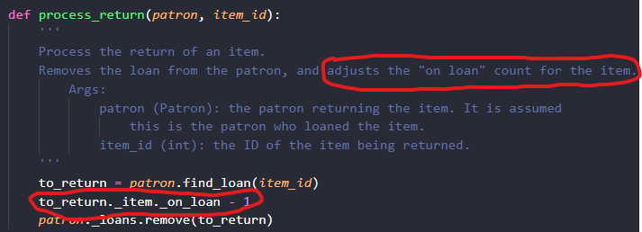

Steps to reproduce:
- On main menu, enter ‘2’ to continue to the return item screen
- Input the name and age of the patron returning an item, e.g. “John Doe”, 95
- Select an item on loan to return, e.g. item 1, then process_return will execute and attempt to decrement the on_loan value.

Expected behaviour:
John Doe will have item 1 removed from their loans, and the on_loan value of item 1 in the catalogue data will be decremented by 1 (on_loan = 1 becomes on_loan = 0).

Actual behaviour:
John Doe will have item 1 removed from their loans, however the on_loan value of item 1 in the catalogue data stays the same (on_loan = 1).
Bug Report 2
Description:
There is an inconsistent length of loan allowed for borrowing a book for up to a number of weeks compared to the other items. Patrons can borrow a book for 1 day less than up to 8 weeks (55 days instead of 56 days), while gardening tools and carpentry tools can be borrowed for up to 4 weeks (28 days) and 2 weeks (14 days) respectively.

The bug is highlighted in red below, the length_of_loan is ‘>=’ 56 rather than ‘>’ 56:
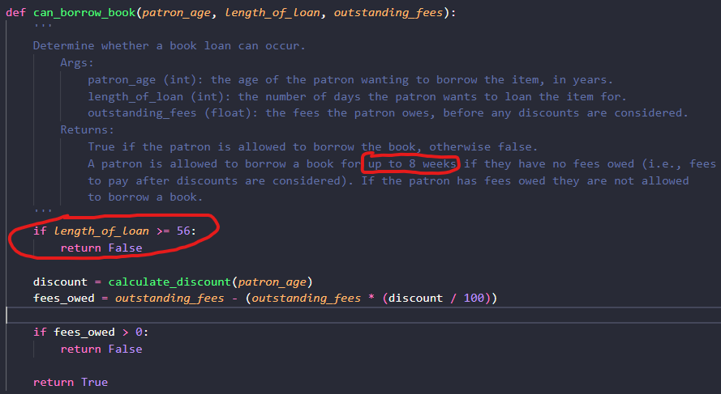

Steps to reproduce:
- On main menu, enter ‘1’ to continue to the loan item screen
- Select a book to loan, e.g. item 2, and confirm it is the item we want to loan, i.e. ‘y’
- Input the name and age of the patron loaning the book, e.g. “John Doe”, 95
- Enter the longest length of loan that should be allowed, i.e. 56 days

Expected behaviour:
Book is successfully on loan to John Doe for 56 days, with print statement: “Loan of The Lord of the Rings by J.R.R. Tolkien to John Doe successfully recorded”

Actual behaviour:
Book loan is unsuccessful, with print statement: “Sorry, John Doe is not able to borrow The Lord of the Rings by J.R.R. Tolkien”

Bug Report 3
Description:
Patrons can borrow more of an item than there is available. The methods can_borrow and related can_borrow item methods and process_loan do not account for the number_owned attribute of the items. No check is done to see if number_owned – on_loan > 0, which would check if the item is available for borrowing, therefore the current logic of the code allows an infinite number of the item to be borrowed, even if the item is unavailable.

Steps to reproduce:
- On main menu, enter ‘1’ to continue to the loan item screen
- Select an item to loan, e.g. item 2, and confirm it is the item we want to loan, i.e. ‘y’
- Input the name and age of the patron loaning the item, e.g. “John Doe”, 95
- Enter a valid length of load, i.e. 4 days. The loan should be successful.
- Repeat step 1-4 the same amount of times as the value of the item’s number_owned (i.e. 4 more times for item 2, since its number_owned = 4), inputting different patrons each time, but loaning the same item. Let the 5th patron loaning item 2 be “Jane Smith”.

Expected behaviour:
The 5th attempt to loan item 2 should be unsuccessful, since item 2’s number_owned is only 4, and all 4 are on loan already. The print statement should be: “Sorry, Jane Smith is not able to borrow The Lord of the Rings by J.R.R. Tolkien”

Actual behaviour:
The 5th attempt to loan item 2 is successful, with print statement: “Loan of The Lord of the Rings by J.R.R. Tolkien to Jane Smith successfully recorded”

